**OLGA KARPENKO, MODERN UNIVERSITY FOR THE HUMANITIES;**

**MARGARITA BERSHADSKAYA, RESEARCH UNIVERSITY - HIGHER SCHOOL OF ECONOMICS**

**Analysis of the results of the international assessment of the content of university sites and its impact on the university web activity**

**The study examines the results of the global ranking** **Webometrics 2007-2014 in the context of the development of mass higher education**

**INTERNATIONAL RANKINGS OF UNIVERSITIES NOT ONLY EVALUATE THE QUALITY OF HIGHER EDUCATION, BUT ALSO INFLUENCE IT ON A GLOBAL SCALE**

**ACADEMIC RANKINGS – SHANGHAI (ARWU), BRITISH (QS,** [**THE TIMES**](http://www.education-medelle.com/articles/rejting-luchschikh-universitetov-mira-ot-the-times-metodologiya.html)**) AND TAIWANESE (PERFORMANCE RANKING OF SCIENTIFIC PAPERS FOR WORLD UNIVERSITIES) – ARE FOCUSED ON THE SELECTION OF LEADING UNIVERSITIES, THUS PROMOTING THE DEVELOPMENT OF ELITE EDUCATION IN THE WORLD AND IN THE NATIONAL SYSTEMS OF HIGHER EDUCATION**

**RANKING WEBOMETRICS (WEB), STIMULATES THE DEVELOPMENT OF ALL UNIVERSITIES IN THE WORLD (NOT ONLY UNIVERSITIES-LEADERS**) **AND THEREBY MAKES A SIGNIFICANT CONTRIBUTION TO IMPROVING THE ACCESSIBILITY OF HIGHER EDUCATION** ***WORLDWIDE***

**OF THE RECOGNIZED GLOBAL UNIVERSITY RANKINGS ONLY ONE - WEBOMETRICS RANKING OF WORLD UNIVERSITIES - STIMULATES THE DEVELOPMENT NOT ONLY THE ELITE BUT ALSO OF MASS HIGHER EDUCATION BOTH GLOBALLY**  **AND IN EACH INDIVIDUAL COUNTRY.**

**THE MAIN IDEAS OF WEBOMETRICS RANKING**

* **-** **THE GROWTH OF ONLINE PUBLICATIONS;**
* **- INCREASE OF COMMUNICATION BETWEEN SCIENTISTS AND EDUCATORS;**
* **- CREATION OF NEW TIES;**
* **- THE SPEED, SIMPLICITY AND EFFICIENCY OF INFORMATION EXCHANGE**

BROAD COVERAGE OF UNIVERSITIES (**20 THOUSAND RANKED UNIVERSITIES,** COMPARED WITH 200-700 UNIVERSITIES IN OTHER GLOBAL RANKINGS) OPENS UP **THE POSSIBILITY OF COMPREHENSIVE** **REGULAR ANALYSIS OF NATIONAL EDUCATIONAL SYSTEMS**. BEING FOLLOWERS OF MASS EDUCATION, WE REGULARLY PUBLISH THE RESULTS OF THE RATING, COMPARING NATIONAL SYSTEMS OF HIGHER EDUCATION **WITH REGARD TO THE SCALE FACTOR.**

**NUMBER OF RANKED UNIVERSITIES**

**2007-2014**

**WEBOMETRICS RANKS 20 000 UNIVERSITIES ACCORDING TO THEIR INTERNET PRESENCE**

**A NEW ASPECT OF LEADERSHIP**

**Due to the wide coverage of universities there appeared the opportunity to compare the systems of higher education not only by individual universities-leaders, BUT BY THE FULL RANGE OF UNIVERSITIES IN THE SYSTEM**

**BROAD OPPORTUNITIES FOR THE DEVELOPMENT OF UNIVERSITIES**

**BASED ON THE ANALYSIS OF THE RESULTS OF THE RANKING ALMOST EVERY UNIVERSITY OF THE WORLD GETS THE OPPORTUNITY TO IDENTIFY ITS STRENGTHS AND WEAKNESSES AND PROPERLY ADJUST THE EDUCATIONAL AND SCIENTIFIC ACTIVITY**

**THE NUMBER OF NATIONAL UNIVERSITIES AMONG THOUSANDS OF THE BEST UNIVERSITIES OF THE WORLD CHARACTERIZES THE MAGNITUDE OF HIGHER EDUCATION SYSTEM OF THE COUNTRY**

**Analysis of the results of Webometrics leads to a quantitative expression of TWO IMPORTANT ASPECTS OF THE DEVELOPMENT OF MASS HIGHER EDUCATION IN THE WORLD:**

**1)** **THE NUMBER OF RANKED NATIONAL UNIVERSITIES, WHICH CHARACTERIZES THE MAGNITUDE OF THE NATIONAL SYSTEM OF HIGHER EDUCATION (TOP 22000);**

**2) THE NUMBER OF UNIVERSITIES IN THE COUNTRY INCLUDED IN 5 OR 10 THOUSAND BEST UNIVERSITIES IN THE WORLD (TOP 5 000 OR TOP 10 000), DIVIDED BY THE TOTAL NUMBER OF THE COUNTRY'S UNIVERSITIES RANKED - AN INDICATOR *INDIRECTLY* CHARACTERIZING THE QUALITY OF MASS EDUCATION IN THE COUNTRY.**

|  |  |
| --- | --- |
| **WEBOMETRICS RANKING INDICATORS** | |
| **2004-2011** | **2012-2014** |
| **VISIBILITY (weight 50%)**  **the total number of unique external links received by a site from Yahoo Search** | **VISIBILITY (50%)**  **IMPACT** (weight 50%)  **THE QUALITY OF THE CONTENTS IS EVALUATED THROUGH A "VIRTUAL REFERENDUM", COUNTING ALL THE EXTERNAL INLINKS THAT THE UNIVERSITY WEBDOMAIN RECEIVES FROM THIRD PARTIES. THE LINK VISIBILITY DATA IS COLLECTED FROM THE TWO MOST IMPORTANT PROVIDERS OF THIS INFORMATION:** [**MAJESTIC SEO**](http://www.majesticseo.com/) **AND** [**AHREFS**](http://ahrefs.com/) |
| **SIZE**  **(weight 25% in 2004-08, 20% in** **2009)**  **number of pages recovered from four engines: Google, Yahoo, Live Search and Exalead** | **ACTIVITY (50%)** |
| **PRESENCE - 1/3** (weight 16,67%)  **THE TOTAL NUMBER OF WEBPAGES HOSTED IN THE MAIN WEBDOMAIN (INCLUDING ALL THE SUBDOMAINS AND DIRECTORIES) OF THE UNIVERSITY AS INDEXED BY THE LARGEST COMMERCIAL SEARCH ENGINE (**[**GOOGLE**](http://www.google.com/)**). IT COUNTS EVERY WEBPAGE, INCLUDING ALL THE FORMATS RECOGNIZED INDIVIDUALLY BY GOOGLE, BOTH STATIC AND DYNAMIC PAGES AND OTHER RICH FILES.** |
| **RICH FILES**  **(weight 12,5% in 2004-08, 15% in 2009)**  **the availability of different file formats such as Adobe Acrobat (.pdf), Adobe PostScript (.ps), Microsoft Word (.doc) and Microsoft Powerpoint (.ppt)** | **OPENNESS** - **1/3** (weight 16,67%)  **THE GLOBAL EFFORT TO SET UP INSTITUTIONAL RESEARCH REPOSITORIES IS EXPLICITLY RECOGNIZED IN THIS INDICATOR THAT TAKES INTO ACCOUNT THE NUMBER OF RICH FILES (PDF, DOC, DOCX, PPT) PUBLISHED IN DEDICATED WEBSITES ACCORDING TO THE ACADEMIC SEARCH ENGINE** [**GOOGLE SCHOLAR**](http://scholar.google.com/) **THE OBJECTIVE IS TO CONSIDER RECENT PUBLICATIONS THAT NOW ARE THOSE PUBLISHED BETWEEN 2008 AND 2012 (NEW PERIOD).** |
| **SCHOLAR**  **(weight 12,5% in** **2004-08, 15% in 2009)**  **the number of papers and citations for each academic domain provided by Google Scholar. These results from the Scholar database represent papers, reports and other academic items.** | **EXCELLENCE**  **- 1/3** (weight 16,67%)  **THE ACADEMIC PAPERS PUBLISHED IN HIGH IMPACT INTERNATIONAL JOURNALS. THE INDICATOR IS RESTRICTED TO ONLY THOSE EXCELLENT PUBLICATIONS, I.E. THE UNIVERSITY SCIENTIFIC OUTPUT BEING PART OF THE 10% MOST CITED PAPERS IN THEIR RESPECTIVE SCIENTIFIC FIELDS. ALTHOUGH THIS IS A MEASURE OF HIGH QUALITY OUTPUT OF RESEARCH INSTITUTIONS, THE DATA PROVIDER** [**SCIMAGO GROUP**](http://www.scimagoir.com/) **SUPPLIED NON-ZERO VALUES FOR MORE THAN 5200 UNIVERSITIES (PERIOD 2003-2010)** |

**ТРИ АСПЕКТА АНАЛИЗА**

**1**

**СОПОСТАВЛЕНИЕ НАЦИОНАЛЬНЫХ СИСТЕМ ВЫСШЕГО ОБРАЗОВАНИЯ С УЧЕТОМ ФАКТОРА МАСШТАБА**

**T THREE ASPECTS OF THE ANALLYSIS**

**1**

**COMPARISON OF NATIONAL HIGHER EDUCATION SYSTEMS WITH REGARD TO THE SCALE FACTOR.**

**2**

**THE DYNAMICS OF GROWTH OF WEB ACTIVITY OF RUSSIAN UNIVERSITIES, INCLUDING REGIONAL (COMPARISON BY FEDERAL DISTRICTS OF THE RUSSIAN FEDERATION)**

**3**

**FEATURES OF WEB ACTIVITY OF RUSSIAN UNIVERSITIES TAKING INTO ACCOUNT THE CHANGES IN CERTAIN INDICATORS**

1. **THE SCALE OF NATIONAL HIGHER EDUCATION SYSTEMS**

**WHEN ANALYZING THE RESULTS OF WEBOMETRICS WE HAVE REPEATEDLY STRESSED THAT AMONG A LARGE NUMBER OF UNIVERSITIES BEING RANKED, THE NUMBER OF NATIONAL UNIVERSITIES WHICH WERE INCLUDED INTO THE CATEGORY OF THE BEST UNIVERSITIES OF THE WORLD IS BECOMING AN IMPORTANT INDICATOR CHARACTERIZING THE SYSTEM OF HIGHER EDUCATION OF THE COUNTRY.**

**STARTING WITH JANUARY 2012, WEBOMETRICS RANKS 20 000 UNIVERSITIES OF THE WORLD. SUCH SCALE OF STUDIES IS PRESENTED FOR THE FIRST TIME**

**NUMBER OF NATIONAL UNIVERSITIES**

**The sharp increase in the number of universities being ranked in 2012-2014 revealed the scale of the system of higher education in such countries as *India* (3rd place in the total number of universities ranked), *Mexico, Iran, Poland, Indonesia*, *Pakistan, Ukraine, Columbia, Philippines, Morocco* *(yellow bars)***

**Out of 255 countries surveyed in the ranking, only 22 countries have more than 200 national universities in the top 22,000. Among them 10 countries (yellow bars) for the first time entered the leading category**

**The results of the top 22 000 - clear evidence of the growing scale of higher education systems in developing countries: 10 developing countries out of 22 best***(Brazil, India, China, Mexico, Iran, Indonesia, Pakistan, Columbia, Philippines, Morocco)* **count total 7471 universities in the top 22000, which is about 70% of 22000 ranked universities**

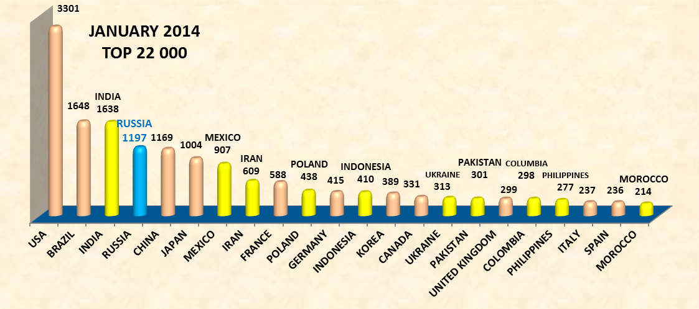

**5823**

**LEADERSHIP OF NATIONAL SYSTEMS OF HIGHER EDUCATION WITH REGARD TO THE SCALE FACTOR – *AN IMPORTANT INDICATOR OF THE DEVELOPMENT OF MASS EDUCATION IN THE COUNTRY***

**THE FIRST TIME WE MENTIONED THIS NEW ASPECT OF LEADERSHIP IN 2007, WHEN ANALYSING TOP 5000 UNIVERSITIES WE FOUND THAT ONLY 10 COUNTRIES OUT OF 191 HAD NO LESS THAN 100 UNIVERSITIES AMONG 5000 WORLD BEST SCHOOLS. RUSSIA ENTERED THE TOP 10 COUNTRIES (7-TH PLACE), FOR THE FIRST TIME TAKING THE LEADING POSITION IN THE RANKING OF WORLD UNIVERSITIES.**

**In the January rankings 2012-2014 about 8 to 10 countries had no less than 100 universities in the top 5000; Russia took the 6th place in January 2014 and the 4th place in the January rankings in 2012 and 2013**

**THE NUMBER OF RANKED UNIVERSITIES**



**THERE IS ANOTHER ASPECT OF LEADERSHIP ARISING FROM THE RESULTS OF THE ANALYSIS OF THE RANKING COVERING THOUSANDS OF WORLD UNIVERSITIES. As stated by the drafters of the ranking in July 2013 even in the United States after the top 5000 there are still about 2,000 universities appearing in subsequent sampling.** **The same pattern is in January 2014. And even after the top 10,000 about 20% of U.S. universities remains "overboard" .**

**IT IS IMPORTANT TO COMPARE THE SIMILAR INDICATORS OF DIFFERENT COUNTRIES** **AS THEY ALLOW TO INDIRECTLY ESTIMATE THE QUALITY OF MASS EDUCATION IN THE COUNTRY.**

**UNDOUBTEDLY AMONG THE GIVEN GROUP OF COUNTRIES IS THE ABSOLUTE LEADERSHIP OF** ***CHINA*: 65.5% RANKED CHINESE UNIVERSITIES ENTERED 5 THOUSAND WORLD BEST UNIVERSITIES AND 92% IN 10 THOUSAND**

**IN THE U.S. SIMILAR INDICATORS ARE MUCH LOWER THAN IN CHINA: 40% IN THE TOP 5000 AND 81% IN THE TOP 10,000. IN THIS ASPECT OF DEVELOPMENT OF HIGHER EDUCATION *THE USA FOR THE FIRST TIME* *HAVE CONCEDED THE SUPERIORITY.***

**BRAZIL AND INDIA (over 1600 universities in 22 thousand) ARE CHARACTERIZED BY VERY LOW QUALITY SCORES OF MASS HIGHER EDUCATION**

**RUSSIA OCCUPYING THE 4TH PLACE BY THE NUMBER OF RANKED UNIVERSITIES IS NOT AMONG THE MOST SUCCESSFUL COUNTRIES BY THE QUALITY OF MASS HIGHER EDUCATION**

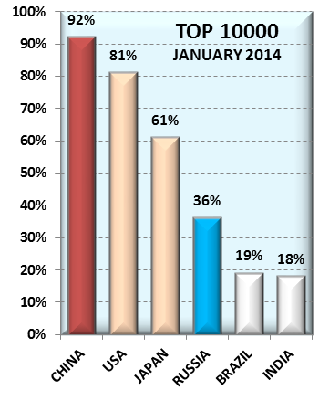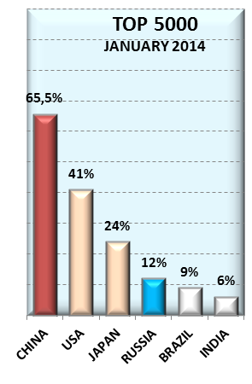

**NUMBER OF RUSSIAN UNIVERSITIES AMONG WORLD’S BEST UNIVERSITIES IN 14 RANKINGS:**

**JULY 2007- JANUARY 2014**

**2.**

**THE DYNAMICS OF GROWTH OF WEB ACTIVITY OF RUSSIAN UNIVERSITIES, INCLUDING REGIONAL UNIVERSITIES**

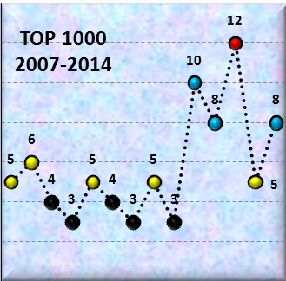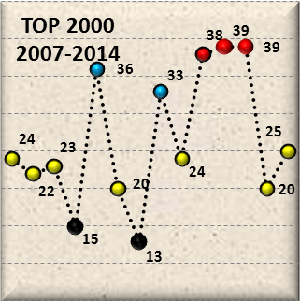

**IN THE TWO MOST RECENT RANKINGS (JULY 2013, JANUARY 2014) RUSSIAN HIGHER EDUCATION INSTITUTIONS AFTER A PERIOD OF SUSTAINED IMPROVEMENT OF THEIR POSITIONS SIGNIFICANTLY WORSENED THE RESULTS TO THE AVERAGE LEVEL (YELLOW COLOUR*).******Is it a random drop - can be judged after the analysis of the two or three subsequent rankings. Nevertheless, it is necessary to think about the reasons now. One of the reasons, probably, is connected with the intensification of the process of modernization of Russian higher education and with some uncertainty of a number of universities in this period. Financial instability in the conditions of modernization of education, of course, is aggravated by the global economic crisis.***

**AS WE CAN SEE, DURING THE CONSIDERED PERIOD (2007-2014) POSITIVE DYNAMICS TAKES PLACE AS A WHOLE.**

**THE BEST RESULTS ARE ACHIEVED IN THREE RANKINGS: JANUARY 2012, JULY 2012, JANUARY 2013.**

**HIGH RESULTS OF RUSSIAN UNIVERSITIES ARE MARKED ON THE CHARTS IN RED AND BLUE**.

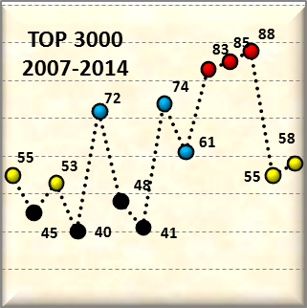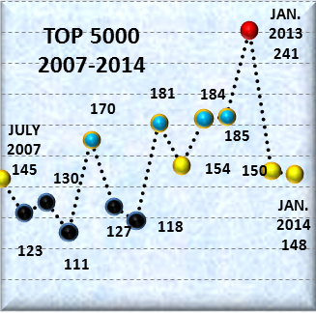

**THE DETERIORATION OF THE POSITION OF RUSSIAN UNIVERSITIES MAY BE DUE TO METHODOLOGICAL CHANGES IN THE RANKINGS. A MAJOR CHANGE IS THE INTRODUCTION OF RESEARCH QUALITY INDICATOR (EXCELLENCE RANK), taking into account the articles in influential international journals and studies included in the 10% most cited papers in the relevant scientific fields. This indicator is a weak point in even the most prestigious Russian universities.** **Hence ONE OF THE MAJOR TASKS OF THE FURTHER DEVELOPMENT - IMPROVING THE QUALITY OF SCIENTIFIC RESEARCH. For 15 national research universities in Russia this problem is put forward at the state level. THE ANALYSIS RESULTS SHOW THE RELEVANCE OF THIS ISSUE FOR THE REGIONAL UNIVERSITIES.**

**THE DYNAMICS OF DEVELOPMENT OF MASS HIGHER EDUCATION IN RUSSIA** **IS CHARACTERIZED BY SIGNIFICANT IMPROVEMENT OF THE POSITION IN JANUARY 2013 WHILE MAINTAINING THE ACHIEVED RESULTS IN 2014.**

**RUSSIA HAS SIGNIFICANTLY IMPROVED ITS PERFORMANCE IN 2013, MOVING FROM THE SEVENTH TO FOURTH PLACE BY THE NUMBER OF RANKED UNIVERSITIES.**

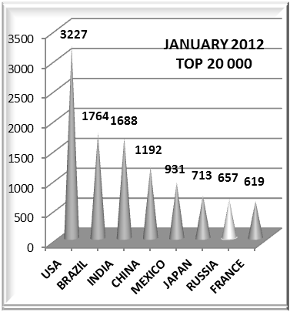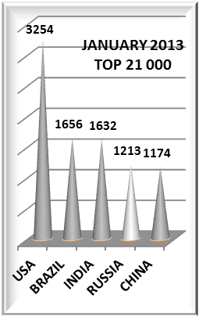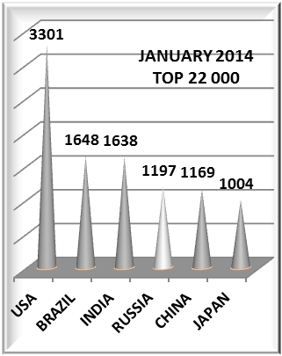

**The increase of Russian universities in the top 20-22 thousand is more than 80% compared with January 2012, which significantly exceeds similar indicators of other countries in the same period. This leap is an important indicator of achievements in the development of Russian mass higher education. SINCE 2013 ALL RUSSIAN UNIVERSITIES ARE AMONG 20 THOUSAND BEST HIGHER EDUCATIONAL INSTITUTIONS OF THE WORLD.**

**INDICATORS OF QUALITY OF MASS HIGHER EDUCATION IN RUSSIA (JANUARY 2014):**

**-THE NUMBER OF RUSSIAN UNIVERSITIES IN THE TOP 10,000 (N10000) IS 36% OF THE NUMBER OF RANKED UNIVERSITIES (N22000);**

**- THE NUMBER OF RUSSIAN UNIVERSITIES IN THE TOP 5000 (N5000) IS 12% OF THE NUMBER OF RANKED UNIVERSITIES (N22000);**

**Besides Russia, compared to 2012, have improved their positions Japan (by 40%), the UK (by 24%), Indonesia (by 16%), Italy (by 12%), Pakistan (by 11%).**

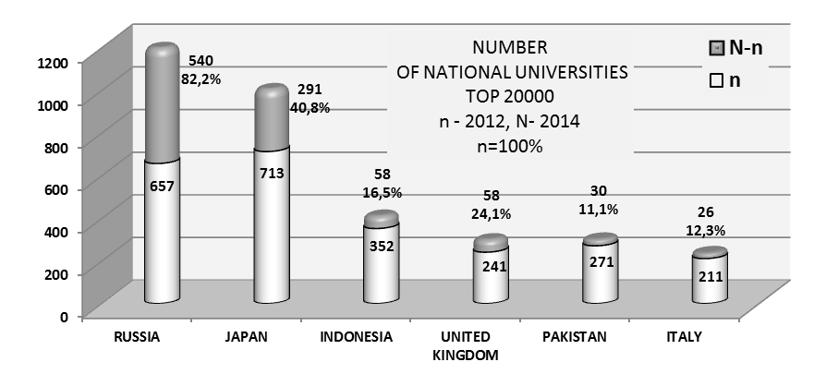

**THE MAIN OBJECTIVE IS THE FURTHER DEVELOPMENT OF THE UNIVERSITIES IN THE REGIONS OF RUSSIA, INCLUDING IMPROVING THE QUALITY OF RESEARCH IN REGIONAL RUSSIAN UNIVERSITIES**

**STARTING FROM THE TOP 4000, RUSSIA IN TERMS OF THE NUMBER OF NATIONAL UNIVERSITIES AMONG THE WORLD'S BEST UNIVERSITIES IS AMONG THE TOP TEN COUNTRIES (8th place)**

**THE RESULTS OF THE LATEST RANKING JAN. 2014**

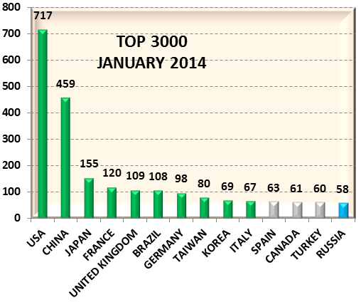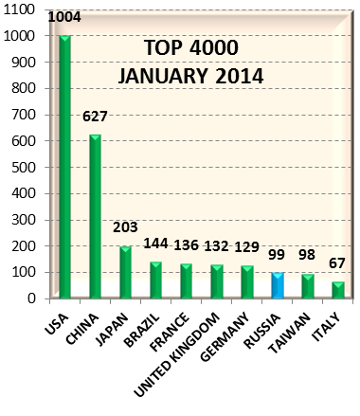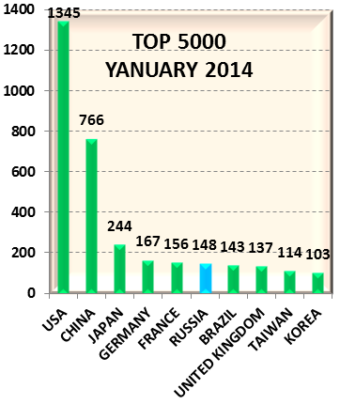

**IN SEVERAL PREVIOUS RANKINGS (INCLUDING JANUARY 2012 JULY 2012, JANUARY 2013) RUSSIA WAS AMONG THE FIRST TEN COUNTRIES, STARTING WITH THE TOP 3000.**

**8-th AND 6-th PLACES IN THE TOP 4000 AND TOP 5000 IN THE LATEST RANKING (JANUARY 2014), COMPARED WITH THE RECORD RESULTS IN PREVIOUS YEARS**

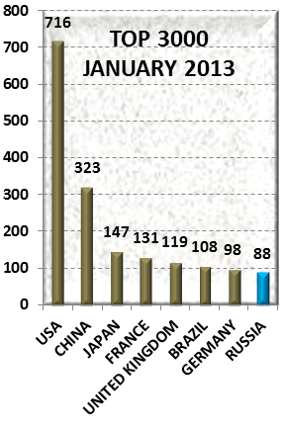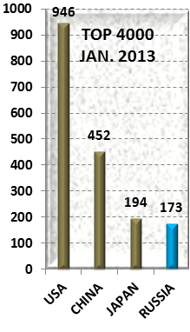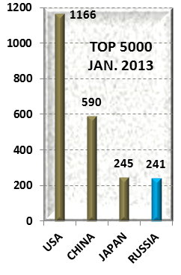

**RECORD RESULTS OF RUSSIAN UNIVERSITIES**

**SIBERIAN UNIVERSITIES BY THEIR POSITIONS ARE MOVING CLOSER TO MOSCOW ;**

**THE UNIVERSITIES OF THE VOLGA FEDERAL DISTRICT ARE ON THE THIRD PLACE**

**AS IN PREVIOUS RANKINGS (2007-2014), UNIVERSITIES OF DIFFERENT REGIONS OF THE COUNTRY (FEDERAL DISTRICTS) ARE AMONG THE BEST UNIVERSITIES OF RUSSIA .**

**MOSCOW UNIVERSITIES ACCOUNT FOR ABOUT 30% OF THE BEST RUSSIAN UNIVERSITIES: IN THE TOP 2000 (7 OF 25), IN THE TOP 3000 (16 OF 58), IN THE TOP 4000 (27 OF 98) AND IN THE TOP 5000 (38 OF 148).**

**RUSSIAN REGIONS IN THE WORLD EDUCATIONAL SPACE**

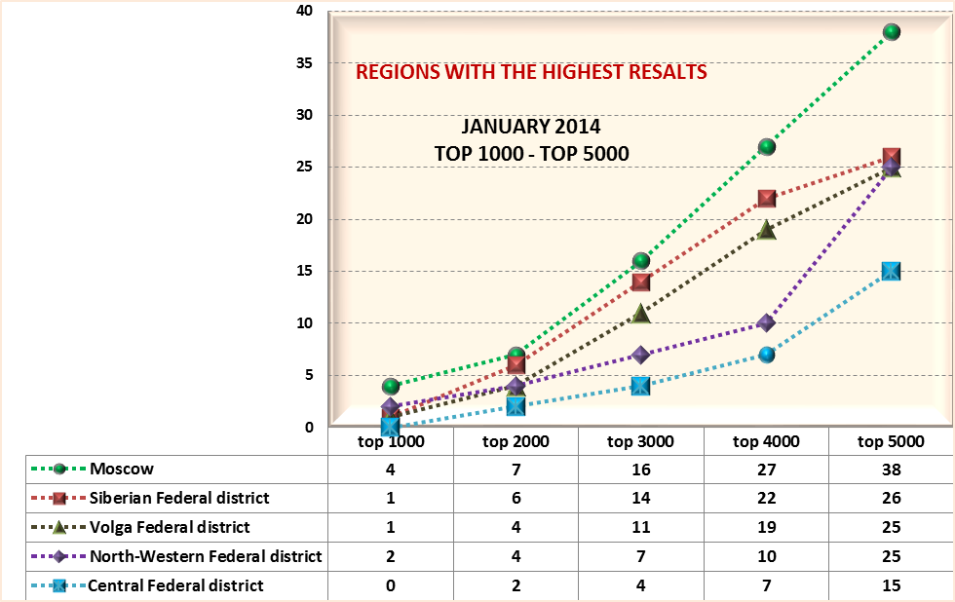

**THE WEAKEST OF THE FEDERAL DISTRICTS - THE NORTH CAUCASUS AND THE FAR EAST**

**THE POSITION OF RUSSIAN UNIVERSITIES DURING THE YEAR (JANUARY 2014 AND 2013 RANKINGS) WITH THE DISTRIBUTION BY FEDERAL DISTRICTS**



**AMONG THE TOP 5000 THERE ARE 241 RUSSIAN UNIVERSITIES IN JANUARY 2013 AND 148 IN JANUARY 2014 RANKING;**

**- THE POSITION OF ALL FEDERAL DISTRICTS HAS WORSENED.**

**- THE NUMBER OF UNIVERSITIES OF MOSCOW DECREASED BY 20 UNIVERSITIES-**

**IN SIBERIA 15 UNIVERSITIES DROPPED OUT OF** **THE TOP 5000**

**- AMONG THE TOP 4000 THERE ARE 173 RUSSIAN UNIVERSITIES IN JANUARY 2013 AND 99 IN JANUARY 2014 RANKING;**

**- DECREASE IN THE NUMBER OF UNIVERSITIES IN 2014 ( 43%) IS CAUSED BY DETERIORATION OF POSITION IN ALL FEDERAL DISTRICTS INCLUDING MOSCOW;**

**- ESPECIALLY THE NUMBER OF UNIVERSITIES IN THE SIBERIAN AND NORTHWEST DISTRICTS HAS DECREASED: 14 UNIVERSITIES IN EACH.**

**- AMONG THE TOP 3000 UNIVERSITIES OF THE WORLD THERE ARE 88 RUSSIAN UNIVERSITIES IN JANUARY 2013 RANKING AND 58 IN JANUARY 2014 RANKING;**

**-DECREASE IN THE NUMBER OF UNIVERSITIES IN THE TOP 3000 IS CAUSED BY DETERIORATION OF POSITION IN ALL FEDERAL DISTRICTS EXCEPT MOSCOW**

**THE DISTRIBUTION OF THE BEST RUSSIAN UNIVERSITIES BY FEDERAL DISTRICTS (2013-2014) INDICATES THE CRUCIAL ROLE OF REGIONAL UNIVERSITIES IN ACHIEVING A HIGH RANKING RESULTS.**

**THE NUMBER OF UNIVERSITIES IN SIBERIAN AND VOLGA DISTRICTS THAT WERE AMONG THE BEST UNIVERSITIES IN THE WORLD IS SLIGHTLY LESS THAN IN MOSCOW, AT A MUCH LOWER PROPORTION OF DISTRICT UNIVERSITIES IN THE TOTAL NUMBER OF RUSSIAN UNIVERSITIES (10% AND 15% RESPECTIVELY, COMPARED WITH 24% OF MOSCOW UNIVERSITIES).**

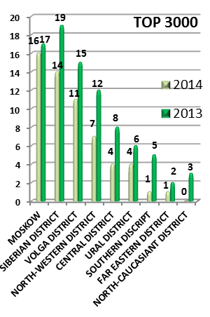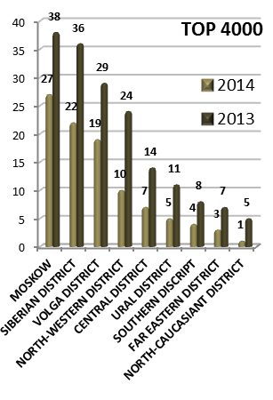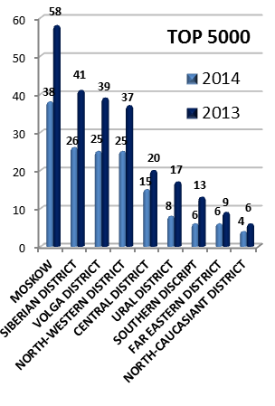

**THE MAIN TASK IS THE DEVELOPMENT OF UNIVERSITIES IN ALL REGIONS OF RUSSIA INCLUDING MOSCOW'S UNIVERSITY SYSTEM, LAGGING BEHIND SIBERIA AND THE VOLGA REGIONS BY INDICATORS (TAKING INTO ACCOUNT THE SHARE IN THE TOTAL NUMBER OF RUSSIAN UNIVERSITIES)**

**3.**

|  |  |  |  |  |
| --- | --- | --- | --- | --- |
| **THE NUMBER OF UNIVERSITIES WITH A HIGH LEVEL OF CERTAIN INDICATORS**  **January 2014**  **OPENNESS RANK** | **NUMBER OF UNIVERSITIES WITH THE POSITIONS** | | | |
| **from 1 to100** | **from 1 to 200** | **from 1 to 500** | **from 1 to1000** |
| **The main feature of January 2013 ranking is a very high level of Openness Rank indicator (blue bars). In January 2014 the number of Russian universities with high positions of this indicator has decreased dramatically (by 5-6 times - red bars). But now, this level is still high compared with the positions in the world ranking (yellow bars): the number of universities with positions Openness in the range 1-1000 almost double the number of Russian universities in one thousand best universities of the world. The number of universities with the indicator Openness in the range 1-500 and 1-200 is 6 times greater than the number of universities with a world ranking from 1 to 500 and 1-200. And even in the range of 1-100 we see 4 universities though there are no universities with the global ranking in this interval.** | **1** | **1** | **4** | **15** |
| **An important achievement of the best Russian universities is a high level of presence in the Internet (Presence Rank) in 2013-2014, and the noticeable improvement of this indicator in 2014.**  **Currently, the number of Russian universities with high positions in Presence Rank greatly exceeds the number of Russian universities in the world ranking in the same range.**  **PRESENCE RANK** | **3** | **7** | **25** | **46** |
| **IMPACT RANK**  **EXCELLENCE RANK** | **1** | **1** | **3** | **14** |
| **THE WEAKEST LINK - INSUFFICIENT QUALITY OF SCIENTIFIC RESEARCH - EXCELLENCE RANK. Only two Russian universities (Lomonosov Moscow State University and Saint Petersburg State University) have relatively high rates.** | **0** | **0** | **1** | **2** |
| **WORLD RANK** | **0** | **1** | **1** | **8** |

**THUS, AN INCREASING NUMBER OF RUSSIAN UNIVERSITIES, PARTICULARLY REGIONAL ONES, ARE IMBUED WITH THE IDEAS OF WEBOMETRICS, OF WHICH THE MOST ATTRACTIVE FOR RUSSIA IS THE EXCHANGE OF SCIENTIFIC INFORMATION THROUGH ONLINE PUBLICATIONS.**

**HIGH PRESENCE RANK ALSO PROMOTES THE EXCHANGE OF EXPERIENCE BETWEEN THE REGIONS OF THE COUNTRY.**

**IN THE CONTEXT OF ECONOMIC CRISIS, COMPLICATING THE FULL-TIME EXCHANGE OF EXPERIENCE BETWEEN REGIONS, THE GROWTH OF THE NETWORK ACTIVITY OF UNIVERSITIES AND ESPECIALLY EXCELLENCE RANK AND PRESENCE RANK, PLAYS A CRUCIAL ROLE FOR THE INTELLECTUAL DEVELOPMENT OF THE REGIONS.**

**Olga Karpenko and Margarita Bershadskaya (presenting): *Analysis of the results of the international assessment of the content of university sites and its impact on the university web activity*** (Abstracts EIPPEE Conference 2014: Workshops & Poster Session, s.15-16)

Of the recognized global university rankings only one - Webometrics Ranking of World Universities - stimulates the development of not only the elite but also of *mass higher education*, both globally and in each individual country. Broad coverage of universities in this ranking (20 thousand ranged universities, compared with 200-700 universities in other global rankings) opens up the possibility of comprehensive regular analysis of national educational systems. Such analysis is the goal of our research since 2007. Being followers of mass education, we regularly publish the results of the rating, comparing national systems of higher education with regard to the scale factor.

Summary of results of 2007-2014 is executed taking into account:

• the evaluation of national higher education systems not only by the positions of the *leading universities*, but also for all national universities;

• the dynamics of growth in online activities of Russian universities, including regional (comparison by federal districts of Russia);

• studying the peculiarities of the network activity of Russian universities with regard to changes of such indicators as Openness Rank and Excellence Rank.

Regular analysis of the results reveals sometimes unexpected facts, such as the entry into the world arena of new countries, considering the scale factor (India, Mexico, Colombia, the Philippines), unique high positions of Russian universities by the indicators characterizing the openness of information and other.

The study examined the growth of web activity of Russian universities as an example of the impact of evidence-based information on the practical activities of universities.

**ИЗ ПРИЗНАННЫХ ГЛОБАЛЬНЫХ РЕЙТИНГОВ УНИВЕРСИТЕТОВ ТОЛЬКО ОДИН - WEBOMETRICS RANKING OF WORLD UNIVERSITIES.- СТИМУЛИРУЕТ РАЗВИТИЕ НЕ ТОЛЬКО ЭЛИТНОГО, НО И МАССОВОГОВЫСШЕГО ОБРАЗОВАНИЯ, КАК В ГЛОБАЛЬНОМ МАСШТАБЕ, ТАК И В КАЖДОЙ ОТДЕЛЬНОЙ СТРАНЕ. ШИРОКИЙ ОХВАТ ВУЗОВ В ЭТОМ РЕЙТИНГЕ (20 ТЫСЯЧ РАНЖИРУЕМЫХ УНИВЕРСИТЕТОВ, ПО СРАВНЕНИЮ С 200-700 ВУЗАМИ В ДРУГИХ ГЛОБАЛЬНЫХ РЕЙТИНГАХ) ОТКРЫВАЕТ ВОЗМОЖНОСТИ МНОГОПРОФИЛЬНОГО РЕГУЛЯРНОГО АНАЛИЗА НАЦИОНАЛЬНЫХ ОБРАЗОВАТЕЛЬНЫХ СИСТЕМ.**

**ОБОБЩЕНИЕ РЕЗУЛЬТАТОВ АНАЛИЗА 2007-2014 ГГ. ВЫПОЛНЕНО В ТРЕХ НАПРАВЛЕНИЯХ:**

**1) ОЦЕНКА НАЦИОНАЛЬНЫХ СИСТЕМ ВЫСШЕГО ОБРАЗОВАНИЯ НЕ ТОЛЬКО ПО ПОЗИЦИЯМ ЛИДИРУЮЩИХ ВУЗОВ, НО И ПО ВСЕЙ СОВОКУПНОСТИ НАЦИОНАЛЬНЫХ УНИВЕРСИТЕТОВ;**

**2) ДИНАМИКА ИЗМЕНЕНИЯ ВЕБ-АКТИВНОСТИ РОССИЙСКИХ УНИВЕРСИТЕТОВ, В ТОМ ЧИСЛЕ РЕГИОНАЛЬНЫХ (СОПОСТАВЛЕНИЕ ПО ФЕДЕРАЛЬНЫМ ОКРУГАМ РФ);**

**3) ИЗУЧЕНИЕ ОСОБЕННОСТЕЙ СЕТЕВОЙ АКТИВНОСТИ РОССИЙСКИХ УНИВЕРСИТЕТОВ**

**.ДЛЯ ОЦЕНКИ НАЦИОНАЛЬНЫХ СИСТЕМ ВЫСШЕГО ОБРАЗОВАНИЯ ПРЕДЛОЖЕНО КОЛИЧЕСТВЕННОЕ ВЫРАЖЕНИЕ ДВУХ ВАЖНЫХ АСПЕКТОВ РАЗВИТИЯ МАССОВОГО ВЫСШЕГО ОБРАЗОВАНИЯ В СТРАНАХ МИРА:**

**1) КОЛИЧЕСТВО РАНЖИРОВАННЫХ НАЦИОНАЛЬНЫХ УНИВЕРСИТЕТОВ, ХАРАКТЕРИЗУЮЩЕЕ МАСШТАБНОСТЬ НАЦИОНАЛЬНОЙ СИСТЕМЫ ВЫСШЕГО ОБРАЗОВАНИЯ;**

**2) КОЛИЧЕСТВО УНИВЕРСИТЕТОВ СТРАНЫ, ВОШЕДШИХ В 10 ИЛИ 5 ТЫС. ЛУЧШИХ УНИВЕРСИТЕТОВ МИРА, ОТНЕСЕННОЕ К ОБЩЕМУ КОЛИЧЕСТВУ РАНЖИРОВАННЫХ УНИВЕРСИТЕТОВ ДАННОЙ СТРАНЫ - ПОКАЗАТЕЛЬ, *КОСВЕННО* ХАРАКТЕРИЗУЮЩИЙ КАЧЕСТВО МАССОВОГО ОБРАЗОВАНИЯ В СТРАНЕ.**

**РЕЗУЛЬТАТЫ ОЦЕНКИ:**

**- УВЕЛИЧЕНИЕ ЧИСЛА РАНЖИРУЕМЫХ ВУЗОВ В 2012 ГОДУ ПОКАЗАЛО МАСШТАБНОСТЬ СИСТЕМЫ ВЫСШЕГО ОБРАЗОВАНИЯ ТАКИХ СТРАН, КАК ИНДИЯ, МЕКСИКА, ИРАН, ПОЛЬША, ИНДОНЕЗИЯ, ПАКИСТАН, УКРАИНА, КОЛУМБИЯ, ФИЛИППИНЫ;**

**- В КАЧЕСТВЕ ФАКТА, ХАРАКТЕРИЗУЮЩЕГО РАЗВИТИЕ МАССОВОГО ОБРАЗОВАНИЯ В ГЛОБАЛЬНОМ МАСШТАБЕ, СЛЕДУЕТ ОТМЕТИТЬ РАЗВИТИЕ ВЫСШЕГО ОБРАЗОВАНИЯ В РАЗВИВАЮЩИХСЯ СТРАНАХ: В 2014 ГОДУ СРЕДИ 22 СТРАН С МАСШТАБНЫМИ СИСТЕМАМИ ВЫСШЕГО ОБРАЗОВАНИЯ (БОЛЕЕ 200 РАНЖИРОВАННЫХ УНИВЕРСИТЕТОВ) ОТМЕЧЕНО 10 РАЗВИВАЮЩИХСЯ СТРАН;**

**- РЕЗУЛЬТАТЫ РОССИЙСКИХ УНИВЕРСИТЕТОВ 2012-2014 (УВЕЛИЧЕНИЕ ЧИСЛА РАНЖИРОВАННЫХ ВУЗОВ НА 82%) ПОЛОЖИТЕЛЬНО ХАРАКТЕРИЗУЮТ РАЗВИТИЕ МАССОВОГО ОБРАЗОВАНИЯ В РОССИИ: С 2013 ГОДА *ВСЕ* РОССИЙСКИЕ УНИВЕРСИТЕТЫ ВХОДЯТ В ЧИСЛО 20 ТЫС. ЛУЧШИХ ВУЗОВ МИРА. КРОМЕ РОССИИ, ИЗ 22 СТРАН ПО СРАВНЕНИЮ С 2012 Г. УЛУЧШИЛИ СВОИ ПОЗИЦИИ ЯПОНИЯ (НА 40%), ВЕЛИКОБРИТАНИЯ (НА 24%), ИНДОНЕЗИЯ (НА 16%), ИТАЛИЯ (НА 12%), ПАКИСТАН (НА 11%);**

**- СОПОСТАВЛЕНИЕ ПРЕДЛОЖЕННЫХ ПОКАЗАТЕЛЕЙ КАЧЕСТВА МАССОВОГО ОБРАЗОВАНИЯ В СТРАНАХ МИРА ПОКАЗАЛО АБСОЛЮТНОЕ ЛИДЕРСТВО КИТАЯ СРЕДИ 22-Х СТРАН С МАСШТАБНЫМИ СИСТЕМАМИ ВЫСШЕГО ОБРАЗОВАНИЯ. США, ЛИДИРУЮЩИЕ В ОБЛАСТИ ВЫСШЕГО ОБРАЗОВАНИЯ, ВПЕРВЫЕ УСТУПИЛИ ПЕРВЕНСТВО. РОССИЯ, ЗАНИМАЮЩАЯ 4 МЕСТО ПО МАСШТАБНОСТИ СИСТЕМЫ, ПО ПОКАЗАТЕЛЯМ КАЧЕСТВА МАССОВОГО ВЫСШЕГО ОБРАЗОВАНИЯ НЕ ОТНОСИТСЯ К ЧИСЛУ УСПЕШНЫХ СТРАН.**

**ВЕБ-АКТИВНОСТЬ РОССИЙСКИХ УНИВЕРСИТЕТОВ:**

**- НАЧИНАЯ С ТОП 3000 – ТОП 4000, В МИРОВОМ ОБРАЗОВАТЕЛЬНОМ ПРОСТРАНСТВЕ ПРЕДСТАВЛЕНЫ УНИВЕРСИТЕТЫ ВСЕХ ФЕДЕРАЛЬНЫХ ОКРУГОВ РОССИИ. В ТЕЧЕНИЕ ВСЕГО ПЕРИОДА ИССЛЕДОВАНИЙ СРЕДИ ЛУЧШИХ ВУЗОВ РОССИИ ОТМЕЧАЕТСЯ ПРЕОБЛАДАНИЕ РЕГИОНАЛЬНЫХ УНИВЕРСИТЕТОВ.**

**- В ТЕЧЕНИЕ РАССМОТРЕННОГО ПЕРИОДА (14 РЕЙТИНГОВ 2007-2014) В ЦЕЛОМ ИМЕЕТ МЕСТО ПОЛОЖИТЕЛЬНАЯ ДИНАМИКА РАЗВИТИЯ, В КОТОРОЙ ВАЖНУЮ РОЛЬ ИГРАЮТ УНИВЕРСИТЕТЫ ВСЕХ РЕГИОНОВ РОССИИ. АНАЛИЗ РЕЗУЛЬТАТОВ КАЖДОГО РЕЙТИНГА ОКАЗЫВАЕТ ВЛИЯНИЕ НА ПРАКТИЧЕСКУЮ ДЕЯТЕЛЬНОСТЬ УНИВЕРСИТЕТОВ.**

**- В ДВУХ ПОСЛЕДНИХ РЕЙТИНГАХ (ИЮЛЬ 2013, ЯНВАРЬ 2014) ПОСЛЕ ПЕРИОДА СТАБИЛЬНО ВЫСОКИХ РЕЗУЛЬТАТОВ РОССИЙСКИЕ ВУЗЫ (И ОСОБЕННО РЕГИОНАЛЬНЫЕ) ЗАМЕТНО УХУДШИЛИ ПОЗИЦИИ ПО СРАВНЕНИЮ С РЕКОРДНЫМИ РЕЗУЛЬТАТАМИ ТРЕХ ПРЕДЫДУЩИХ РЕЙТИНГОВ. НАИБОЛЕЕ ВЕРОЯТНАЯ ПРИЧИНА – ИЗМЕНЕНИЯ В МЕТОДОЛОГИИ С УСИЛЕНИЕМ РОЛИ ИНДИКАТОРА КАЧЕСТВА НАУЧНЫХ ИССЛЕДОВАНИЙ.**

**ОСОБЕННОСТИ ВЕБ-АКТИВНОСТИ РОССИЙСКИХ УНИВЕРСИТЕТОВ**

**ВСЕ БОЛЬШЕЕ КОЛИЧЕСТВО РОССИЙСКИХ ВУЗОВ, ОСОБЕННО РЕГИОНАЛЬНЫХ, ПРОНИКАЕТСЯ ИДЕЯМИ WEBOMETRICS, ИЗ КОТОРЫХ НАИБОЛЕЕ ПРИВЛЕКАТЕЛЬНОЙ ДЛЯ РОССИИ ЯВЛЯЕТСЯ ОБМЕН НАУЧНОЙ ИНФОРМАЦИЕЙ ЗА СЧЕТ ОНЛАЙН ПУБЛИКАЦИЙ - ВЫСОКИЙ УРОВЕНЬ ОТКРЫТОСТИ (OPENNESS RANK). ВЫСОКИЙ ПОКАЗАТЕЛЬ ПРИСУТСТВИЯ В ИНТЕРНЕТЕ (PRESENCE RANK) ТАКЖЕ СПОСОБСТВУЕТ ОБМЕНУ ОПЫТОМ МЕЖДУ РЕГИОНАМИ СТРАНЫ. СЛАБОЕ ЗВЕНО – НЕДОСТАТОЧНОЕ КАЧЕСТВО НАУЧНЫХ ИССЛЕДОВАНИЙ.**

**КАЖДОЕ ИЗ ТРЕХ НАПРАВЛЕНИЙ ИССЛЕДОВАНИЙ ВЫДВИГАЕТ В КАЧЕСТВЕ ОСНОВНОЙ ЗАДАЧИ ДАЛЬНЕЙШЕГО РАЗВИТИЯ РОССИЙСКИХ УНИВЕРСИТЕТОВ ПОВЫШЕНИЕ КАЧЕСТВА НАУЧНЫХ ИССЛЕДОВАНИЙ**

**OLGA KARPENKO dn@muh.ru **

**MARGARITA BERSHADSKAYA beriandr@mail.ru** 

***THANK YOU FOR YOUR ATTENTION***